Data Transmission Using Multi-Tasking-Sockets

(Documentation)

-Introduction
-Project Description
-Project Analysis
-Software specifications
-Project Requirements
-Module Design
-Output Design

Project Analysis

Introduction

This article is about a client/server multi-threaded socket class. The thread is optional since the developer is still responsible to decide if needs it. There are other Socket classes here and other places over the Internet but none of them can provide feedback (event detection) to your application like this one does. It provides you with the following events detection: connection established, connection dropped, connection failed and data reception (including 0 byte packet).

Description
This article presents a new socket class which supports both TCP and UDP communication. But it provides some advantages compared to other classes that you may find here or on some other Socket Programming articles. First of all, this class doesn't have any limitation like the need to provide a window handle to be used. This limitation is bad if all you want is a simple console application. So this library doesn't have such a limitation. It also provides threading support automatically for you, which handles the socket connection and disconnection to a peer. It also features some options not yet found in any socket classes that I have seen so far. It supports both client and server sockets. A server socket can be referred as to a socket that can accept many connections. And a client socket is a socket that is connected to server socket. You may still use this class to communicate between two applications without establishing a connection. In the latter case, you will want to create two UDP server sockets (one for each application). This class also helps reduce coding need to create chat-like applications and IPC (Inter-Process Communication) between two or more applications (processes). Reliable communication between two peers is also supported with TCP/IP with error handling. You may want to use the smart addressing operation to control the destination of the data being transmitted (UDP only). TCP operation of this class deals only with communication between two peers.

Analysis of Network Client Server

TCP/IP stack
The TCP/IP stack is shorter than the OSI one:
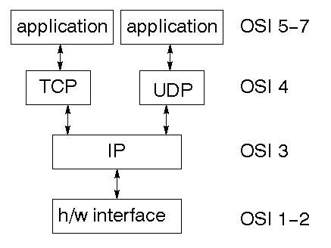
TCP is a connection-oriented protocol; UDP (User Datagram Protocol) is a connectionless protocol.

IP datagram’s
The IP layer provides a connectionless and unreliable delivery system. It considers each datagram independently of the others. Any association between datagram must be supplied by the higher layers. The IP layer supplies a checksum that includes its own header. The header includes the source and destination addresses. The IP layer handles routing through an Internet. It is also responsible for breaking up large datagram into smaller ones for transmission and reassembling them at the other end.

UDP
UDP is also connectionless and unreliable. What it adds to IP is a checksum for the contents of the datagram and port numbers. These are used to give a client/server model - see later.

TCP
TCP supplies logic to give a reliable connection-oriented protocol above IP. It provides a virtual circuit that two processes can use to communicate.

Internet addresses
In order to use a service, you must be able to find it. The Internet uses an address scheme for machines so that they can be located. The address is a 32 bit integer which gives the IP address. This encodes a network ID and more addressing. The network ID falls into various classes according to the size of the network address.

Network address
Class A uses 8 bits for the network address with 24 bits left over for other addressing. Class B uses 16 bit network addressing. Class C uses 24 bit network addressing and class D uses all 32.

Subnet address
Internally, the UNIX network is divided into sub networks. Building 11 is currently on one sub network and uses 10-bit addressing, allowing 1024 different hosts.

Host address
8 bits are finally used for host addresses within our subnet. This places a limit of 256 machines that can be on the subnet.

Total address
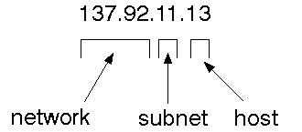
The 32 bit address is usually written as 4 integers separated by dots.

Port addresses
A service exists on a host, and is identified by its port. This is a 16 bit number. To send a message to a server, you send it to the port for that service of the host that it is running on. This is not location transparency! Certain of these ports are "well known".

Sockets
A socket is a data structure maintained by the system to handle network connections. A socket is created using the call socket. It returns an integer that is like a file descriptor. In fact, under Windows, this handle can be used with ReadFile and WriteFile functions.
#include <sys/types.h>
#include <sys/socket.h>
int socket(int family, int type, int protocol);
Here "family" will be AF_INET for IP communications, protocol will be zero, and type will depend on whether TCP or UDP is used. Two processes wishing to communicate over a network create a socket each. These are similar to two ends of a pipe - but the actual pipe does not yet exist.

Module Design Specification

part 1 - Create a server socket that listen for a client to
connect
part 2 - send / receive data from client to server
part 3 - Read unknow size of data from client

Create a server socket that listens for a client to connect

socket(int af, int type, int protocol)
This method creates the socket
bind(SOCKET s, const struct sockaddr FAR * name, int namelen)
Associates a local address with a socket This routine is used on an unconnected datagram or stream socket, before subsequent connects or listens. When a socket is created with socket, it exists in a name space (address family), but it has no name assigned. bind establishes the local association (host address/port number) of the socket by assigning a local name to an unnamed socket. In the Internet address family, a name consists of several components. For SOCK_DGRAM and SOCK_STREAM, the name consists of three parts: a host address, the protocol number (set implicitly to UDP or TCP, respectively), and a port number which identifies the application. If an application does not care what address is assigned to it, it may specify an Internet address equal to INADDR_ANY, a port equal to 0, or both. If the Internet address is equal to INADDR_ANY, any appropriate network interface will be used; this simplifies application programming in the presence of multi- homed hosts. If the port is specified as 0, the Windows Sockets implementation will assign a unique port to the application with a value between 1024 and 5000. The application may use getsockname after bind to learn the address that has been assigned to it, but note that getsockname will not necessarily fill in the Internet address until the socket is connected, since several Internet addresses may be valid if the host is multi-homed. If no error occurs, bind returns 0. Otherwise, it returns SOCKET_ERROR, and a specific error code may be retrieved by calling WSAGetLastError.
listen(SOCKET s, int backlog )
Establishes a socket to listen to a incoming connection To accept connections, a socket is first created with socket, a backlog for incoming connections is specified with listen, and then the connections are accepted with accept. listen applies only to sockets that support connections, i.e. those of type SOCK_STREAM. The socket s is put into "passive'' mode where incoming connections are acknowledged and queued pending acceptance by the process. This function is typically used by servers that could have more than one connection request at a time: if a connection request arrives with the queue full, the client will receive an error with an indication of WSAECONNREFUSED. listen
attempts to continue to function rationally when there are no available descriptors. It will accept connections until the queue is emptied. If descriptors become available, a later call to listen or accept will re-fill the queue to the current or most recent "backlog'', if possible, and resume listening for incoming connections.
accept(SOCKET s, struct sockaddr FAR * addr, int FAR * addrlen)
This routine extracts the first connection on the queue of pending connections on s, creates a new socket with the same properties as s and returns a handle to the new socket. If no pending connections are present on the queue, and the socket is not marked as non- blocking, accept blocks the caller until a connection is present. If the socket is marked non-blocking and no pending connections are present on the queue, accept returns an error as described below. The accepted socket may not be used to accept more connections. The original socket remains open. The argument addr is a result parameter that is filled in with the address of the connecting entity, as known to the communications layer. The exact format of the addr parameter is determined by the address family in which the communication is occurring. The addrlen is a value-result parameter; it should initially contain the amount of space pointed to by addr; on return it will contain the actual length (in bytes) of the address returned. This call is used with connection-based socket types such as SOCK_STREAM. If addr and/or addrlen are equal to NULL, then no information about the remote address of the accepted socket is returned.
closesocket(SOCKET s)
closes a socket

Making client connection with server
In order to create a socket that connects to an other socket uses most of the functions from the previous code with the exception of a struct called HOSTENT
HOSTENT:
This struct is used to tell the socket to which computer and port to connect to. These struct can appear as LPHOSTENT, but it actually means that they are pointer to HOSTENT.

Client key function
Most of the functions that have been used for the client to connect to the server are the same as the server with the exception of a few. I will just go through the different functions that have been used for the client.
gethostbyname(const char* FAR name)
gethostbyname returns a pointer to a hostent structure as described under gethostbyaddr. The contents of this structure correspond to the hostname name. The pointer which is returned points to a structure which is allocated by the Windows Sockets implementation. The application must never attempt to modify this structure or to free any of its components. Furthermore, only one copy of this structure is allocated per thread, and so the application should copy any information which it needs before issuing any other Windows Sockets API calls. A gethostbyname implementation must not resolve IP address strings passed to it. Such a request should be treated exactly as if an unknown host name were passed. An application with an IP address string to resolve should use inet_addr to convert the string to an IP address, then gethostbyaddr to obtain the hostent structure.

Part 2 - Send / recieve
Up to this point we have managed to connect with our client to the server. Clearly this is not going to be enough in a real-life application. In this section we are going to look into more details how to use the send/recv functions in order to get some communication going between the two applications.
Factually this is not going to be difficult because most of the hard work has been done setting up the server and the client app. before going into the code we are going to look into more details the two functions
send(SOCKET s, const char FAR * buf, int len, int flags)
send is used on connected datagram or stream sockets and is used to write outgoing data on a socket. For datagram sockets, care must be taken not to exceed the maximum IP packet size of the underlying subnets, which is given by the iMaxUdpDg element in the WSAData structure returned by WSAStartup. If the data is too long to pass atomically through the underlying protocol the error WSAEMSGSIZE is returned, and no data is transmitted.

recv(SOCKET s, const char FAR * buf, int len, int flags)
For sockets of type SOCK_STREAM, as much information as is currently available up to the size of the buffer supplied is returned. If the socket has been configured for in- line reception of out-of-band data (socket option SO_OOBINLINE) and out-of-band data is unread, only out-of-band data will be returned. The application may use the ioctlsocket SIOCATMARK to determine whether any more out-of-band data remains to be read.

part 3 - Read unknow size of data from client
Us mentioned earlier in part 2, we are noe going to expand on the way that we receive data. The problem we had before is that if we did not know the size of data that we where expecting, then the would end up with problems.
In order to fix this here we create a new function that receive a pointer to the client socket, and then read a char at the time, placing each char into a vector until we find the '\n' character that signifies the end of the message.
This solution is clearly not a robust or industrial way the read data from one socket to an other, because but its a way to start reading unknown length strings. the function will be called after the accept method

JAVA
WHAT IS JAVA?
Java has two things: a programming language and a platform.
Java is a high-level programming language that is all of the following

Simple Architecture-neutral
Object-oriented Portable
Distributed High-performance
Interpreted multithreaded
Robust Dynamic & Secure

Java is also unusual in that each Java program is
both compiled and interpreted. With a compile
you translate a Java program into an intermediate language
called Java bytecodes the platform-independent code
instruction is passed and run on the computer.
Compilation happens just once; interpretation occurs each
time the program is executed. The figure illustrates how this works.
Java Program
Compilers
Interpreter
My Program
You can think of Java byte codes as the machine code instructions for the Java Virtual Machine (Java VM). Every Java interpreter, whether it’s a Java development tool or a Web browser that can run Java applets, is an implementation of the Java VM. The Java VM can also be implemented in hardware.
Java byte codes help make “write once, run anywhere” possible. You can compile your Java program into byte codes on my platform that has a Java compiler. The byte codes can then be run any implementation of the Java VM. For example, the same Java program can run Windows NT, Solaris, and Macintosh.
JAVA PLATFORM
A platform is the hardware of software environment in which a program runs. The Java platform differs from most other platforms in that it’s a software only platform that runs on the top of other, hardware-based platform. Most other platforms are described as a combination of hardware and operating system.

The Java platform has two components:
The Java Virtual Machine (Java VM)
The Java Application Programming Interface (Java API)
You’ve already been introduced to the Java VM. It’s the base for the Java platform and is ported onto various hardware-based platforms.
The Java API is a large collection of ready-made software components that provide many useful capabilities, such as graphical user interface (GUI) widgets.
The Java API is grouped into libraries (package) of related components. The next sections, what can Java do? Highlights each area of functionally provided by the package in the Java API.

The following figure depicts a Java program, such as an application or applet, that’s running on the Java platform. A special kind of application known as a server serves and supports clients on a network. Examples of the servers include Web Servers, proxy servers, mail servers, print servers, and boot servers. Another specialized program is a Servlet. Servlets are similar to applets in that they are runtime extensions of the application. Instead of working in browsers, though, servlets run with in Java Web Servers, configuring of tailoring the server.

How does the Java API support all of these kinds of programs? With packages of software components that provide a wide range of functionality. The API is the API included in every full implementation of the platform.
The core API gives you the following features:
The Essentials: Objects, Strings, threads, numbers, input and output, datastructures, system properties, date and time, and so on.
Applets: The set of conventions used by Java applets.
Networking: URL’s TCP and UDP sockets and IP addresses.
Internationalization: Help for writing programs that can be localized for users.
Worldwide programs can automatically adapt to specific locates and be displayed in the appropriate language.

JAVA PROGRAM
- Java API
- Java Virtual Machine
- Java Program
- Hard Ware

API and Virtual Machine insulates the Java program from hardware dependencies. As a platform-independent environment, Java can be a bit slower than native code. However, smart compilers, well-tuned interpreters, and Just-in-time-byte-code compilers can bring Java’s performance close to the native code without threatening portability.
WHAT CAN JAVA DO?
However, Java is not just for writing cut, entertaining applets for the World Wide Web (WWW). Java is a general purpose, high-level programming language and a powerful software platform. Using the fineries Java API,you can write many types of programs.
The most common types of program are probably applets and application, where a Java application is a standalone program that runs directly on the Java platform.
Security:
Both low-level and high-level, including electronic signatures, public/private key management, accesses control, and certificate.

Requirement Specification

Software Requirement specification
Hardware Requirement specification

Software Requirement Specification:

Language: JDK1.3

Platform: Windows and Linux (platform Independent)

Client: Own Client designed Using Java Socket.

Server: Server designed Using Java Server Socket

Development Tool: JCreator.

Hardware Requirement Specification:

RAM: 128MB (Minimum).

Processor: Pentium 2 and above.

Processor Speed: Above 500 MHz.

Layer Description:

Physical Layer, Date Link Layer.

Functional Description

- Transmitting Message and Files between Client and Server.

- The data will be valid until the Server is Valid.

- Everything defined as Object oriented.

- Server has been developed using Server Socket programming in Java.

- Client has been developed using Socket Programming.

- Transmitting data between Client and Server has been developed IP
address.

- We are running it as Server Client in PC itself.

- We can convert it to internet server and client processing by

- Implementing POP3 protocol and SMTP server.

- Because of Object Oriented Technology it is very Easy to Convert.

- We have Used Data file to store username and password.

- Usage of Sql Server will not be needed for sending Messages and attachments.

Module Classification

Client based:

E mail Client ( )

E mail ( ) (maintenance)

User ( )

Server based:

E mail Server ( )
In Box:
Inbox List( )

Recipient List( )

Design view:
Font Change( )

Main Function menu GUI( )

Main Login menu GUI( )

Read Mail Window GUI( )

Send Mail Window GUI( )

View Graphics Attachments( )

View Media Attachments( )

View text Attachments( )

Operations involved in E Mail Clients

E Mail Clients:

This is the module which Handles Client events as follows ,

    - Interacting with Login menu GUI of Design view.

    - Getting User name from server.

    - Sending undeleted mail back to server for storage.

    - Setting up Client Data Storage

    - Shut down the server when finished.

    - Delete mail from Inbox.

    - Send inbox item to server for storage while exit.

    - Create a copy of Inbox backup for UnDeletion.

Operations involved in E Mail Server

E Mail Server :

    - Create new instance of server storage vectors

    - Create new instance of server GUI to display messages

    - Starts the server

    - Set up socket to accept connections

    - Accept new client

    - Update server window details

    - Run indefinitely

    - Starts up the server in the correct manner

    - Extract information for server from files

    - Read object from file and add to server vector

    - Gets a vector of emails from persistent storage

    - Set up file input stream from persistent server file

    - Read object from file and add to server vector

    - Display message and close stream

    - Output server information to persistent storage

    - Sends all server usernames to file

    - Set up new file output stream

    - Update server message window

    - Send all server mail to a file

Operations involved in E Mail Inbox

- Check if there is mail to select

- Get the mail selected by user

- Delete mail from vector

- Update read property of mail

- Update list of emails

- Open email in new mail window

- Delete mail from mail vector

- Display message to user

- Retrieve the backup inbox from client

- Display message to user

- Updates the content of the inbox list

- If mail is unread create different description

- Set inbox window to description of mail

Starting Server:

I update data transaction automatically.

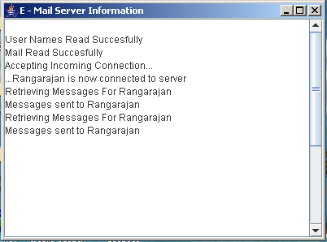

While we are starting Clients the main Login menu display is shown below.

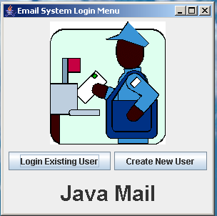

Login User form Getting input for email ID and password from user

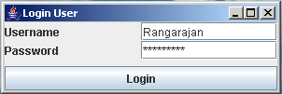

if it is valid ID then Displays

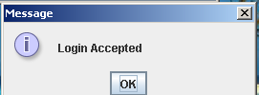

if the user is not valid then the form will be

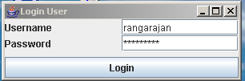

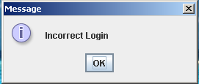

After the user has been entered it displays the form as shown below

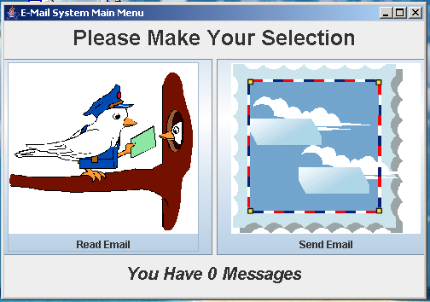

from this the user can select read mail or send mail option
To read the mail from any other clients we have to select Read Email.
To send the mail to any other clients we have to select Send Email.

If the User will select Send Mail option then the display will be

The user has to enter Destination Email ID ,Subject and Message.

If the user wants to attach any more files then press send attachment.

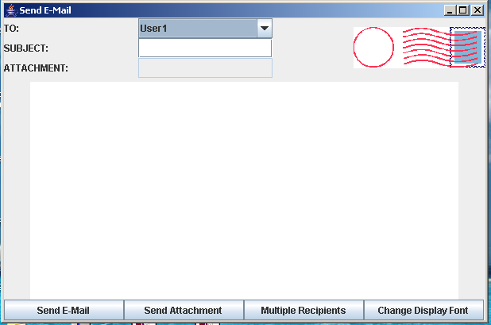

Change Display Font is to change the type of font in Message Box.

If the user selected any attachments then the display will be

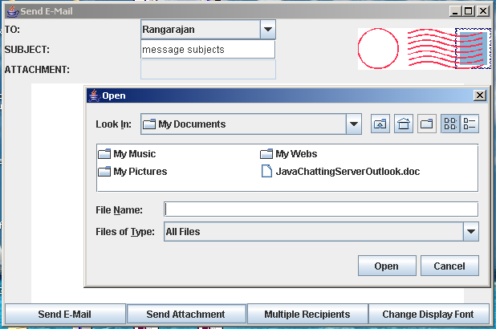

If the user has been attached any files and messages then press sent mail. It displays the message box which has shown below.

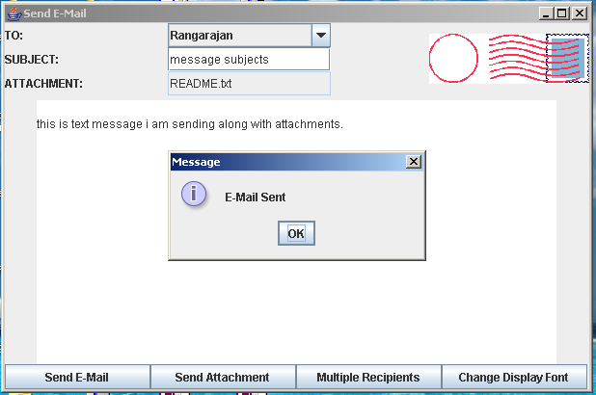

If you have sent the mail to your self then your login section will be

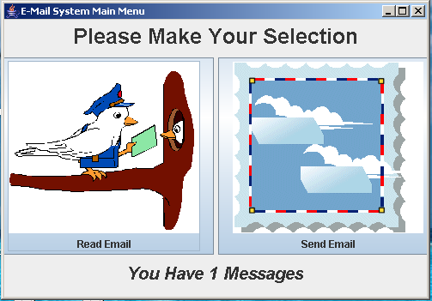

if you have selected read mail option of your login then it shows your attachment
and content in Inbox.
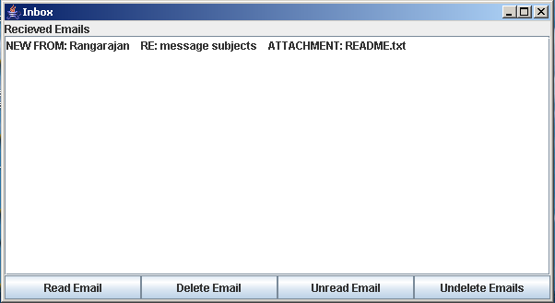

if you are selecting particular mail for Inbox and press read mail then I shown below.

while we press view attachment it displays the content in new window.

